Facebook and Fake News

Consider each of the below proposals, and fill in each of the below TODOs.

# Proposals

## Proposal 1

Facebook relies on an algorithm as well as individual users’ reports to identify content that is potentially "fake news." Once the content has been identified, it is sent to third party fact-checkers for verification. If the content is verified as fake news, it is publicly flagged with a warning that the content is disputed by fact-checkers.

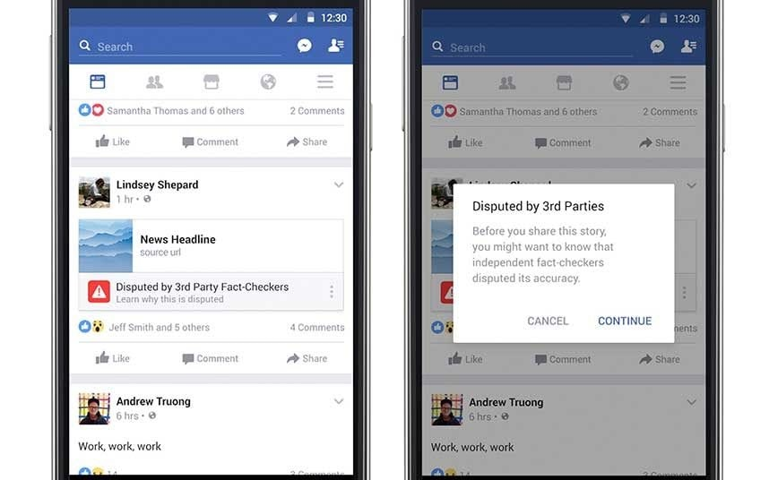

## Proposal 2

However, a designer at Facebook believes that there needs to be a different approach to content regulation. Their proposal is that content deemed problematic by third-party fact-checkers should be prevented from being shared on the platform altogether.

# 

# Questions

1. Which form of content regulation, Proposal 1 or Proposal 2, do you feel is better? Why?
   1. TODO
2. Which form of content regulation, Proposal 1 or Proposal 2, do you think best preserves or promotes the [five rights and opportunities necessary for a democratic public sphere](https://cs50.harvard.edu/college/2020/fall/labs/10/lecture/#five-rights-and-opportunities-for-a-democratic-public-sphere)?
   1. Which proposal best preserves or promotes Rights? Why?
      1. TODO
   2. Which proposal best preserves or promotes Opportunity for Expression? Why?
      1. TODO
   3. Which proposal best preserves or promotes Access? Why?
      1. TODO
   4. Which proposal best preserves or promotes Diversity? Why?
      1. TODO
   5. Which proposal best preserves or promotes Communicative Power? Why?
      1. TODO